How to upload assignments in D2L.

1. Go to the course D2L.
2. Under the Assessments pull down menu choose Assignments.
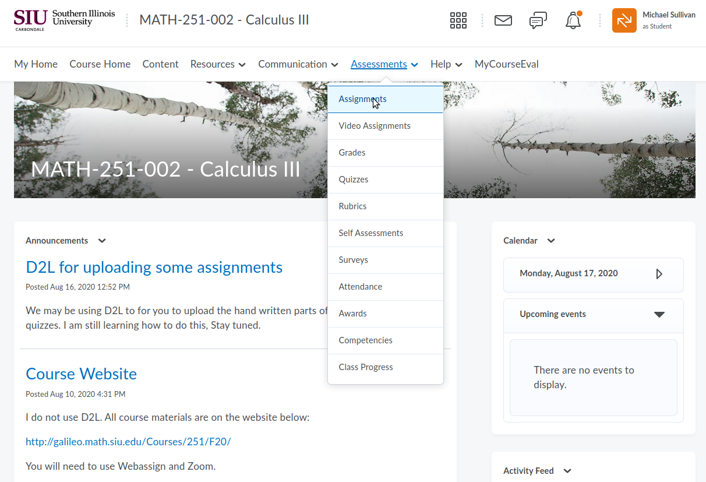

3. You should see a list of the quizzes and hwk sets. Pick the one you want to turn in. I used Quiz 1 below.
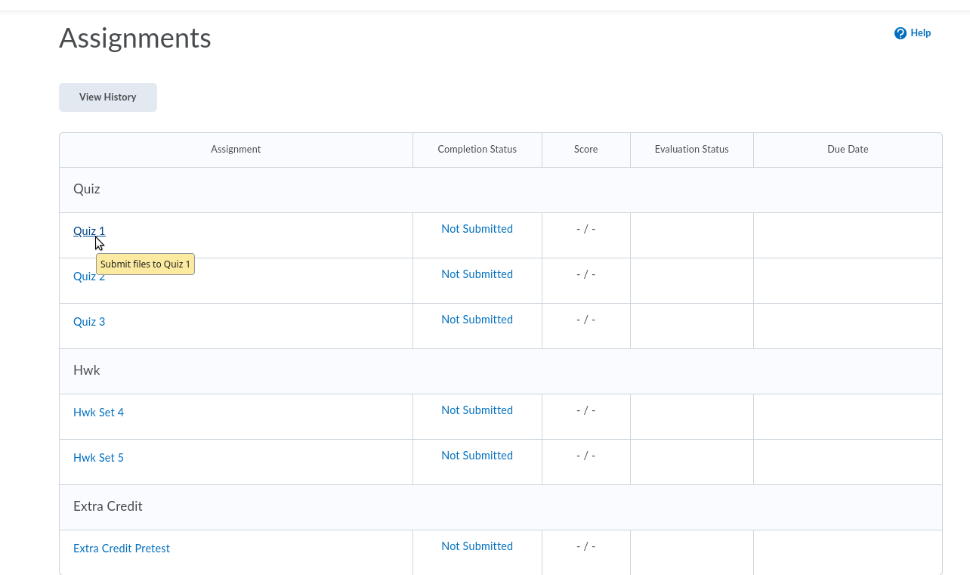

4. Click on the Quiz 1 (in this example). You should see something like this:

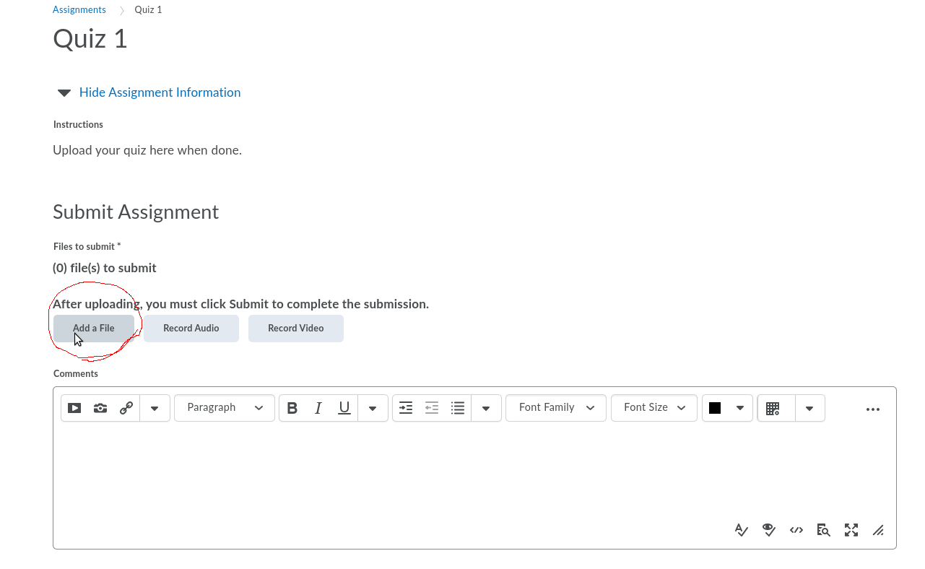

5. Click on Add a File. You should see something like this:
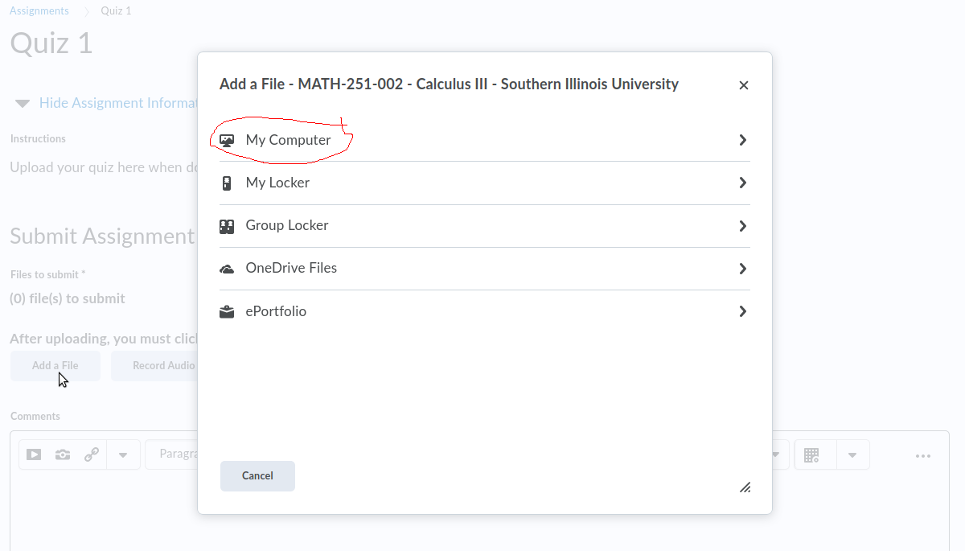

6. Probably you’ll choose My Computer. I do not know anything about the other options. Then you should see something like this:

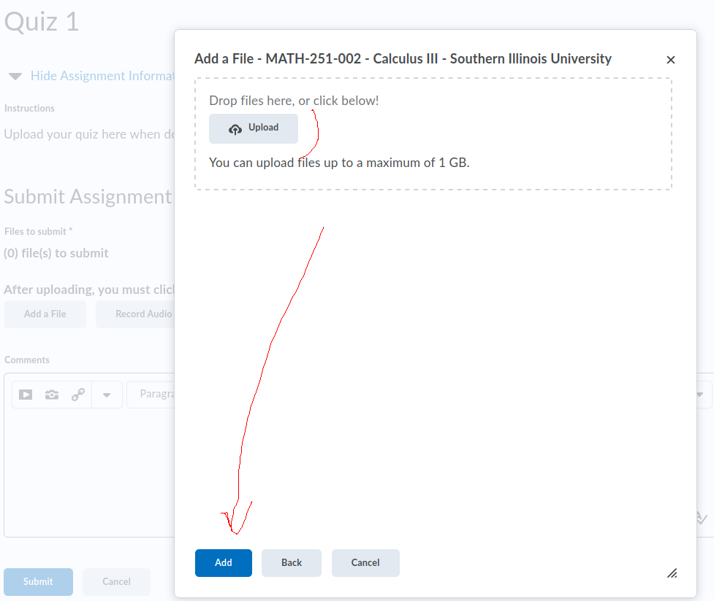

7. Use Upload to choose the file from your computer. Then hit the Add button at the bottom.

